VR Chemistry Module 3 - Physical and Chemical Changes

(updated Wednesday, July 22nd, 2026 by RB and CZL)
(updated Monday, August 10, 2026 in conversation with Cathy Skibo, USC Lab Coordinator

This module will mimic Reaction #1 of Lab Exercise #3 “The Law of Mass Action: Le Chatelier’s Principle” - Page 16 of the CHEM 105B chemistry laboratory manual.

Game Design Specification

Experiment Overview
Module Name: Physical and Chemical Changes Recognition Learning Objectives:

- Le Chatelier’s Principle
- Distinguish between physical and chemical changes by annotating detailed observations
- Recognize signs of chemical reactions (color change, gas production, temperature change)
- Practice proper lab technique with measuring, and mixing.
- Practice proper waste disposal of metal ions.
- Apply critical thinking to classify observed changes

- Apply stress to various chemicals systems in order to observe how the systems react.
- Make detailed qualitative observations about chemical and physical changes.
- Learn to use pH paper and litmus paper to test the acidity/basicity of a solution
- Use detailed observations to understand and explain the concept of Le Châtelier’s Principle as it applies to the systems being studied.

Estimated Duration: 12-15 minutes

Progression System: Linear step-gating - students MUST complete each step successfully before advancing to the next step.

VR Design Philosophy: Minimize fine motor skill requirements. Auto-stopping measurements, button-based controls, and forgiving interactions.

STEP 0: Background
Educational Note Popup: In this experiment, 9 reactions at equilibrium will be perturbed, and the resulting chemical and physical changes will be observed. A physical change (solid, liquid, gas) occurs when matter changes form. A chemical change occurs when new products are formed. For this simulation, you will do reaction #1 from Lab 3: The Law of Mass Action: Le Chatelier’s Principle

Educational Note Popup: Le Chatelier’s Principle allows us to predict the effect of change upon a chemical system in equilibrium. It says that if stress is imposed on a system at equilibrium, the equilibrium concentration of reactants and products will shift in such a manner as to relieve the stress.

STEP 0: Safety First - Put On PPE
Educational Note Popup (appears briefly after equipping): “SAFETY PRECAUTION:
Several of the reactions in this experiment use acids and bases at concentrations ≥ 1M. Make sure your safety table includes all safety hazards. Be extremely careful when using high concentrations of corrosive chemicals such as acids and bases. All spills or drips should be cleaned up immediately as directed by your TA. Be particularly careful not to leave drops of acid or base on the sides of the bottles.”

Step 0: Put On Personal Protective Equipment
Player Instruction: "Before starting any chemistry experiment, you must wear proper Personal Protective Equipment (PPE). Put on your safety goggles and lab coat."

Required Actions:

- Put on safety goggles
- Put on lab coat
- Gloves

Interaction Mechanic:

- Approach PPE station
- Press button for goggles → Auto-equips with animation
- Press button for lab coat → Auto-equips with animation

Success Criteria:

- Both goggles and lab coat equipped
- Visual confirmation (student can see goggles frame edge, lab coat visible on arms)

Feedback:

- Visual:
  - Hand turn blue indicating gloves
  - Checkmarks appear on PPE items once equipped protected for the lab. Remember: always wear PPE before working with chemicals." → Auto-advance to Step 1
- 💡 Hint (15s): "Look for the safety goggles and lab coat at the PPE station. Grab each item and bring it toward your body to put it on."

Educational Note Popup (appears briefly after equipping): "Safety goggles protect your eyes from chemical splashes and flying particles. Lab coats protect your skin and clothing from spills."

Educational Note Popup (appears briefly after equipping): Note: In this lab, you will generate metal ion waste. It will be disposed of in the fume hood. You may also generate glass waste. The test tubes are thrown out in glass waste.

Educational Note Popup (appears briefly as student is about to start): This is a qualitative experiment (no calculations). In a QUALITATIVE experiment, measurements do not have to be exact; detailed observations are what is most important! Look out for changes as you mix things together inside glass test tubes. It is not necessary to determine the actual concentrations of reactants and products to determine if and how a chemical reaction responds to changes in conditions. Be on the lookout for changes in color, precipitation, temperature, etc.

Cannot Proceed Until: Both PPE items equipped

PART 1: Physical Change -

Reaction #1

The chromate-dichromate ion equilibrium

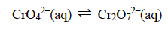

Step 1: Gather Equipment
Educational Note Popup (appears briefly as student is about to start): This is a qualitative experiment (no calculations). In a QUALITATIVE experiment, measurements do not have to be exact; detailed observations are what is most important! In this lab you will be mixing approximately 1ml solutions, this measurement does not have to be exact.
Player Instruction: Gather the following equipment: two test tubes, a test tube rack, 1 glass stir rod, (located inside your lab drawer, below the bench), and a squirt bottle filled with water (should be on the bench). Using a disposable plastic pipette (also on your bench), measure approximately 1 ml of water into one of your test tubes. Use this to estimate the amounts you will be adding in the subsequent reactions. Note

Find the following reagents potassium chromate(K₂Cr₂O₄), sodium hydroxide (NaOH), sulfuric acid (H₂SO₄).

To find these, look around the room. The reagents are located inside the fume hoods. There are several stations like this throughout the lab. The reagents are stored inside a secondary container, separated by their characteristics. In this case, you will find two secondary containers labeled acids or bases, each containing several reagents. The bottles contain liquid inside of them, and will have a disposable pipette taped to them for easy dispensing. Tip: It will be useful to read over the lab and look up which chemicals are acids and which are bases, so you can find what you need faster and also anticipate the resulting changes.
Multiple bottles will be inside one tray.
Two trays inside the fume hood,
The bottles will contain liquids (not solids as in this picture).
Each bottle contains a disposable pipette taped to it, held inside a glass test tube as shown.
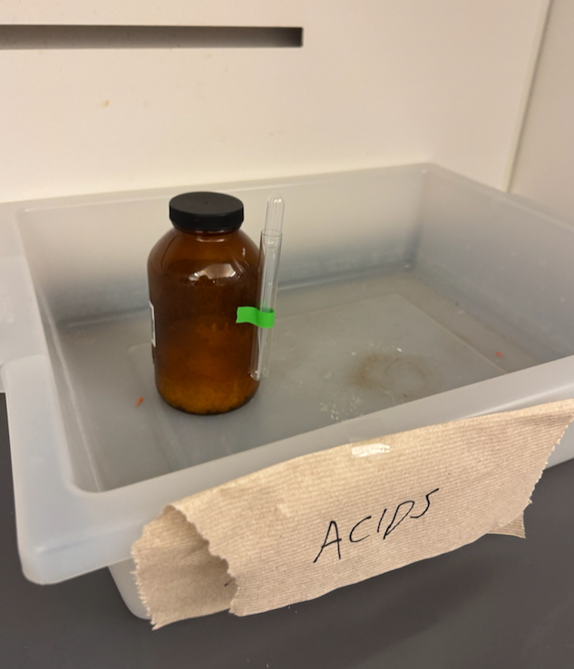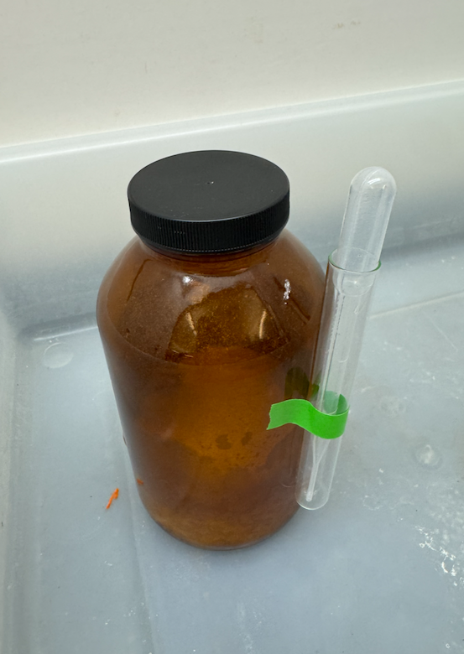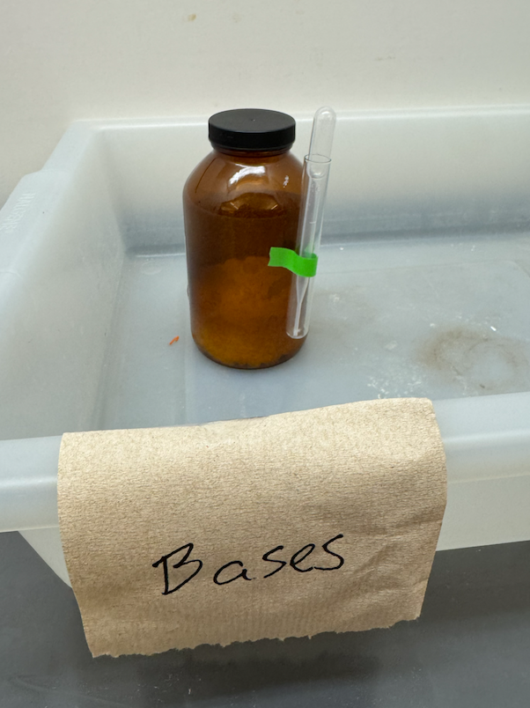

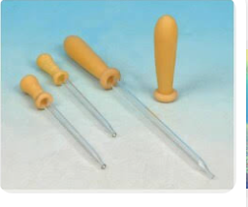
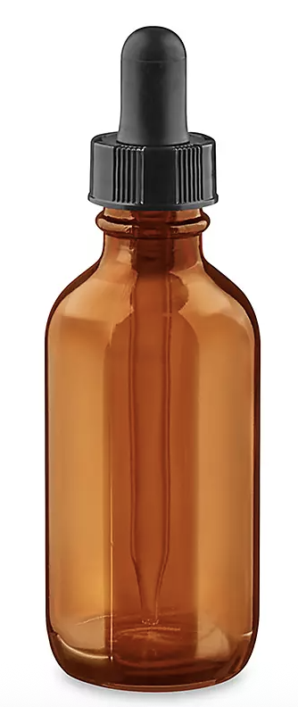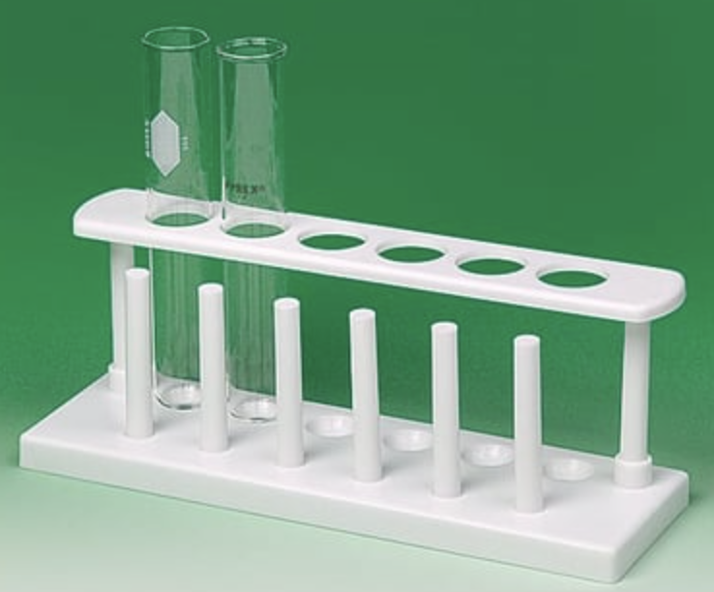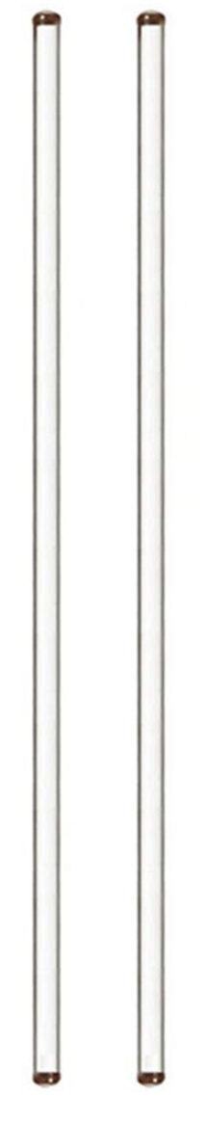
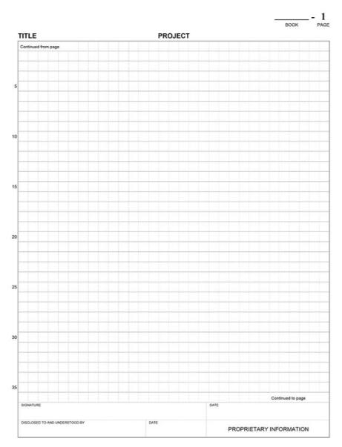

Approximate size of test tubes (hold 19 ml; are 120 mm / 5 inches long).
https://www.fishersci.com/shop/products/fisherbrand-disposable-borosilicate-glass-tubes-plain-end-10/1496130#?keyword=

Black Sharpie, pen and lab notebook are already on the lab bench.

Please insert a picture of what the reagent bottles look like for these reagents: potassium chromate ((K₂Cr₂O₄), sodium hydroxide (NaOH), sulfuric acid ((K₂Cr₂O₄)

Required Actions:

- Pick up and place items in work area or on designated spots
- All items must be collected.
- Place two test tubes inside the test tube rack.
- Pick up one empty test tube, label it test tube #1 with the Sharpie
- Pick up one empty test tube, label it test tube #2 with the Sharpie

Success Criteria:

- All 8 items present in work zone

Feedback:

- ✅ Success: "Good! You have all the equipment needed." → Auto-advance to Step 2
- 💡 Hint (15s): "Look around the lab table for the reagent bottle of potassium chromate, 10 mL graduated cylinder, and stir rod.”

Cannot Proceed Until: All equipment collected

Step 2: Measure 1 mL of 0.1 M potassium chromate solution.
Player Instruction: "Use the graduated cylinder to collect 1 mL of 0.1 M potassium chromate solution. Hold the cylinder under the reagent bottle."

Required Actions:

- Pick up graduated cylinder
- Move to potassium chromate solution (yellow) reagent bottle
- Position cylinder under reagent bottle
- Pour out 1 mL
- Pick up graduated cylinder and pour yellow potassium chromate reagent solution into test tube #1.
- Note show here is what 1mL looks like, use this to approximate 1mL
- (repeat with test tube #2)

Auto-Stop Mechanic:

- Potassium chromate solution (yellow) automatically stops flowing at exactly 1 mL
- Visual/audio cue when target reached
- No overfilling possible

Success Criteria:

- Graduated cylinder positioned under reagent bottle
- Pouring activated into graduated cylinder
- 1 mL reached (automatic)
- Test tubes #1 and 2 positioned under graduated cylinder
- Pouring activated into test tube #1
- Pouring activated into test tube #2
- 1 mL reached (automatic)
- Test tubes #1 and #2 now contain 1 mL of potassium chromate solution (yellow).

Feedback:

- While filling: "Filling... [progress bar or liquid level rises]" Yellow solution can be seen in the graduated cylinder, and later in each of the test tubes.
- Audio: Solution flowing sound
- ✅ Success (at1 mL): Click/chime sound "Excellent! 1 mL collected." → Auto-advance to Step 3
- 💡 Hint (5 s): "Position the graduated cylinder directly under the potassium chromate solution and pull the trigger."

Cannot Proceed Until: 1 mL of potassium chromate solution is measured and poured into test tubes #1 and #2

Step 3: Drop-wise addition of reagents into test tubes.
Player Instruction: "Open the reagent bottle that says 1 M sodium hydroxide, use the dropper”

Required Actions:

- Pick up 1 M sodium hydroxide bottle (colorless liquid) in one hand.
- Pick up the corresponding dropper for this bottle in another hand.
- Put down the 1 M sodium hydroxide bottle
- Position the dropper over test tube #1
- Drop a few drops of 1 M sodium hydroxide solution, dropwise.

Auto-Stop Mechanic:

- When the dropper hovers over the test tube, stop.
- Drops automatically dispenses in small drop-like increments
- Drops are seen going into the test tube and mixing with the solution.
- After four drops, system automatically stops.
- Visual indicator: Green checkmark appears when complete. Also, the solution does not change color?

Success Criteria:

- Dropper properly placed over test tube #1
- Drops of sodium hydroxide are mixing with the potassium chromate solution.
- Exactly 4 drops are achieved (system auto-completes).
- Stirring rod properly placed inside test tube #1
- Stirring motion.
- Stirring rod is removed from inside test tube #1 and placed on counter.

Feedback:

- After the dropper is placed over test tube, system prompts to add drops (push button)
- While adding: drops can be seen entering test tube and mixing with pre-existing solution.
- ✅ Success (at 4 drops): Chime sound "Perfect! 4 drops have been added” → Auto-advance to Step 4
- ⚠️ If not: "Please continue to add drops by pushing the button.”
- 💡 Hint (25s): "Hold the dropper over test tube #1. The system will stop you at exactly 4 drops."

Visual: Test tube one contains slightly more solution (slightly greater than 1 mL).

Cannot Proceed Until: Four drops of 1 M sodium hydroxide solution have been added drop wise with stirring.

Step 4: Stir the Solution
Player Instruction: "Use the glass stir rod to mix the solution inside the test tube until the drops completely dissolve."
Pick up a glass stirring rod.
- Stir test tube #1 with a glass stirring rod.

Required Actions:

- Pick up stir rod
- Place in beaker with solution
- Move in circular stirring motion (OR hold button while stir rod is in beaker)

Stirring Mechanic (Choose easier option):

- Option A: Detect circular hand motion while stir rod in beaker
- Option B: Hold trigger/button while stir rod is in beaker = automatic stirring animation

Success Criteria:

- Stir rod in beaker
- Stirring action for minimum 5 seconds
- Sugar fully dissolved (visual timer completes)

Feedback:

- After the stirring rod is placed over test tube, system prompts to place it inside test tube #1 (push button)
- While stirring, solution moves and mixes.
- ✅ Success after stirring 2 times: Chime sound "Perfect! Solution is sturred → Auto-advance to Step 4
- ⚠️ If not: "Please continue to stir by pushing the button.”
- 💡 Hint (25s): "Hold the stir bar over test tube #1. The system will stop you at exactly after two stirs."

Cannot Proceed Until: 5 seconds of stirring + visual transition complete

Step 5: Record your observations

Question - Physical or Chemical Change?
Player Instruction: "You dissolved sugar in water. The solution is clear and transparent. Is this a physical change or a chemical change?"

UI Element: Two large, easy-to-press buttons

- Button A: "Physical Change" ✅ CORRECT
- Button B: "Chemical Change"

Success Criteria:

- Student selects from several sentences that will mach the observation they see in the test tube.

Feedback:

- ✅ Correct: "That's right! This is a physical change. TBD → Auto-advance to Next Step
- ❌ Incorrect: "Not quite. Think about whether a new substance was created. Try again."
  - Buttons remain active for retry

Cannot Proceed Until: Correct answer selected

Player Instruction: "Record your observations - go to the lab notebook, pick up pen and write what you see? NoTE: this is a classic pH change reaction. Upon base, the solution should change color. Pick up a pen and write in a notebook.”

Required Actions:

- Pick up pen.
- Move over to your lab notebook.
- Writing motion. - perhaps the lab notebook in VR will have pre-written statements and the students just click on the observation they see.

Auto-Transfer Mechanic:

- When the student picks up pen to write, they are hovering above a lab notebook page.
- They are able to view the test tube #1 and lab notebook page.
- The page contains pre-written statements.

Success Criteria:

- Pen picked up
- Positioned over lab notebook page
- Writing triggered (automatic or button press)

Step 6: Add 3 M sulfuric acid (H2SO4) to test tube #2
Player Instruction: ""Open the reagent bottle that says 3 M sulfuric acid, use the dropper”

Repeat all steps above.

Step 7: Add 1 M sodium hydroxide to test tube #2
Player Instruction: ""Open the reagent bottle that says 1M sodium hydroxie, use the dropper”

Repeat all steps above.

WASTE REMINDER: Dispose of waste in the designated waste containers. Metal ion waste should NEVER be poured down the drain. You are not yet qualified to distinguish when acids and bases may be poured down the drain, so you should always dispose of acid/base waste in the designated containers.

ANSWER: Mixing chromate ions (CrO₄²⁻ ) with sodium hydroxide (NaOH) keeps the chromium in its yellow chromate form. Because NaOH is a base, it prevents the solution from becoming acidic, which stops yellow chromate (CrO₄²⁻) from turning into orange dichromate (CrO₇²⁻). No major chemical reaction occurs between them because both contain basic/high-pH stable species.
Chemical Behavior
- pH Effect: NaOH adds hydroxide ions (OH⁻) which remove any free hydrogen ions (H⁺).
- Equilibrium: In chemistry, the balance between chromate and dichromate relies on acid (H⁺). Adding a base like NaOH shifts the balance entirely toward the yellow chromate ion (CrO₄²⁻).
- No Precipitation: Sodium chromate (Na₂CrO₄) remains completely dissolved as a clear yellow liquid.
Safety and Handling
- Corrosive Base: Sodium hydroxide is a strong alkali and causes severe skin burns.
- Chromium Toxicity: Chromate compounds contain hexavalent chromium, which is toxic and harmful to the environment. Always wear gloves and eye protection.

